03/11/2026

Identity, Cost & Learning Platforms:

1 AWS Console access
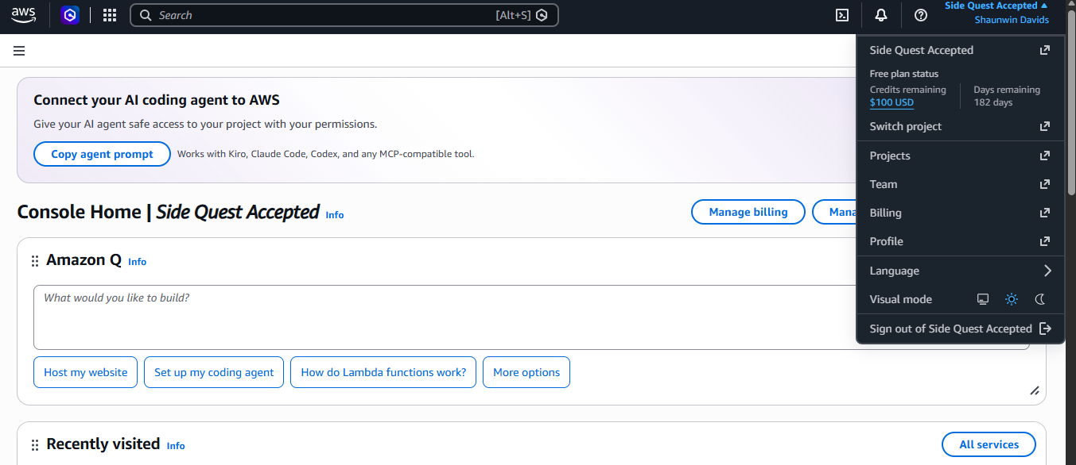

2 Skill Builder
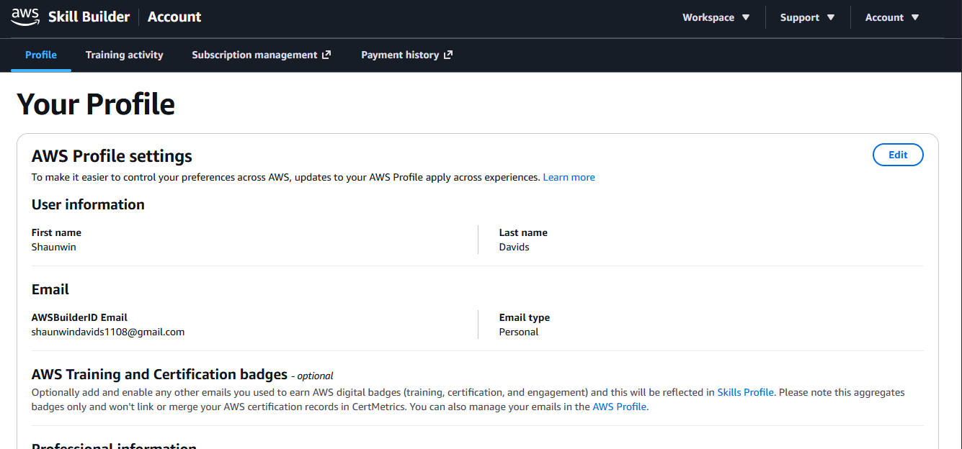

3 Region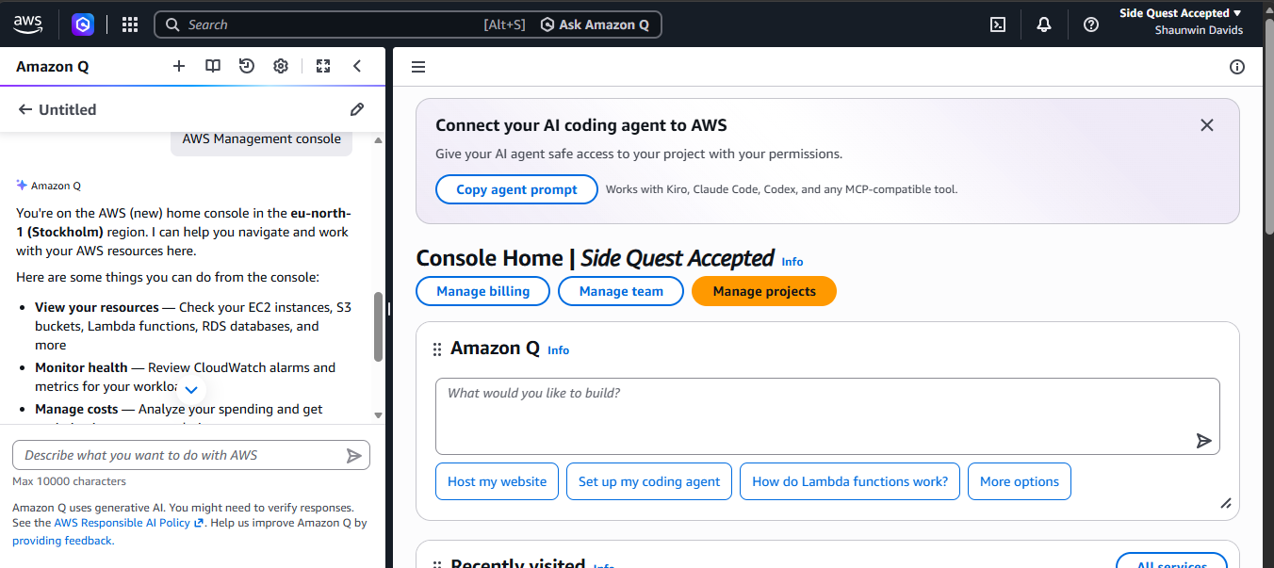
I was unable to change the region to “af-south-1”, for the AWS free tier account comes with selected a region, as shown in the image above.

4 AWS Budget and alarm configuration.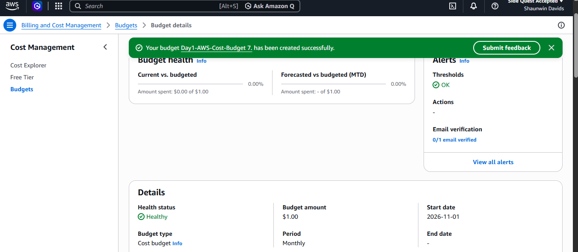

5 MFA enabled
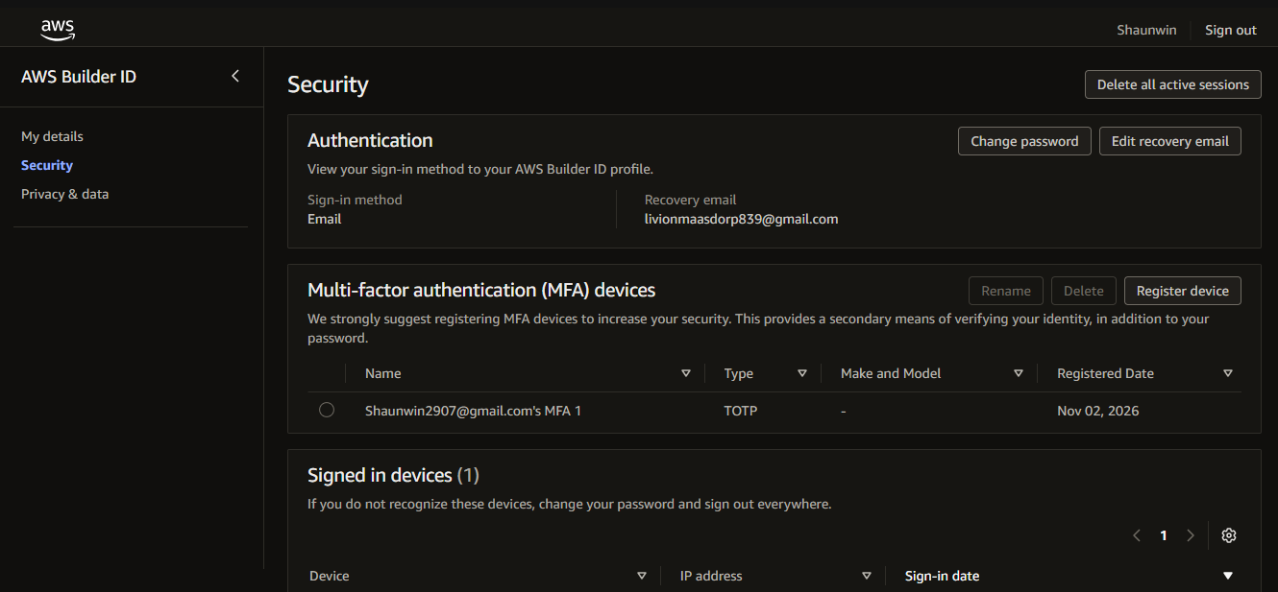

Day 1 Decision Note:
I will protect the AWS root account by enabling MFA and avoid using it for everyday administration. I will create a monthly AWS budget of 1$ and configure alerts to monitor spending and avoid unexpected costs. I have selected AWS Skill Builder as my main learning platform because it provides structured training and AWS certification preparation.

